Kem Chan
CS 405
Sept 23, 2026
Assignment 4- Exceptions

Output of code
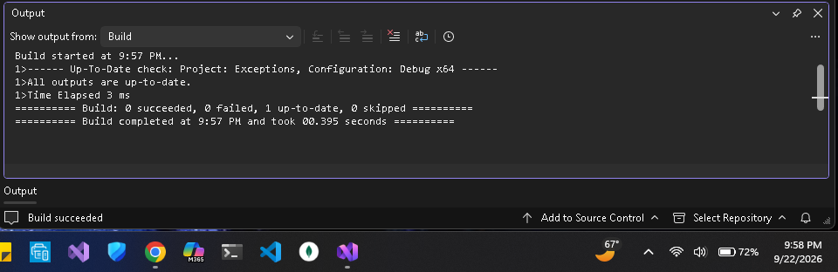

Summary
Looking into this assignment there were multiple scenarios where an exception could be thrown or caught. The first testing purpose of the do_even_more_custom_application_logic() method is constructed to throw a custom exception that is derived from standard exceptions. Looking at the method do_custom_application_logic() inputs a wrap that would call to throwing method into a try/ catch block. The try portion ensures that any exception will be captured and pass it onto the catch block. In this instance the catch block is set to only catch standard exceptions and display error messages. Under the situation it is not a standard exception it will not be caught and could cause programs to fail if not caught elsewhere. The divide(float num, float den) method potentially passes a () for the den parameter, in the scenario that this happens the program would collapse since it would not be divisible to a value of 0 but if it is then an illegal argument exception would be thrown. When the do_division() method would attempt to divide using the other method, the call is wrapped in a try/ catch block. If there is a invalid argument exception is thrown, then the exception is caught, and the display the exception message. Lastly, the method calls in the main() method is wrapped in a try block with several catch blocks organized from the most to least specific. In this case it first tries to catch custom exceptions, then any other standard exceptions, and finally any other exceptions.

